6th EIASM Workshop on Talent Management
Barcelona

ACCOMMODATION

RECOMMENDATIONS

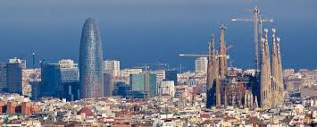
HOTEL EUROPARK
http://www.hoteleuropark.com/en/
Aragó, 323-325, 08009 - Barcelona – Spain
Tel: (+34) 93 457 92 05

Hotel in the heart of Modernist Barcelona:

“The Hotel Europark offers all the services of a modern 3-star Barcelona boutique hotel, including complimentary WiFi internet connection throughout the building, and a spectacular terrace and pool on the eighth floor. (…) On the eighth floor guests can enjoy the magnificent terrace with swimming pool and solarium, or simply stretch out and relax after a hard day touring the city. A unique space right in the heart of Barcelona, the Europark’s eighth-floor haven gives guests a unique opportunity to enjoy the sun and spectacular panoramic views of the city. The terrace is open all year round during day-time, and constitutes a place of total peace and quiet, a unique refuge from the hubbub of the city and ideal for a weekend break in Barcelona.

With the charm of a boutique hotel, the glass-paneled mezzanine-lounge serves as the spectacular breakfast area, where from 7:00-11:00 a.m. guests can enjoy a magnificent hot and cold buffet. For guests departing extra early, we are most happy to provide an Early Coffee breakfast service at the lobby of the hotel (coffee or hot teas).

The Bar offers a unique menu featuring tapas, snacks, and sandwiches, as well as a wide variety of domestic and imported liquors.”

SPECIAL RATES FOR THE CONFERENCE:

- Double Room (individual use): 140€ (VAT included)
- Double Room (double use): 150€ (VAT included)
http://www.hoteleuropark.com/en/rooms/double-barcelona/
Breakfast included!
Touristic tax not included in the price (0.72 € per night and person)
Free WiFi in the entire hotel.

In order to benefit for these special rates just ill in this form (Europark Hotel Reservation form) and send it to: reservas-europark@nnhotels.com, and in the subject of the e-mail write: “Talent Management Workshop”.

TRANSPORT AND GETTING AROUND:

Public transportation from BCN Barcelona Airport - El Prat, to the hotel:

http://www.hoteleuropark.com/en/the-hotel/location/

The hotel is just 8 minutes by walk from the Conference Venue:

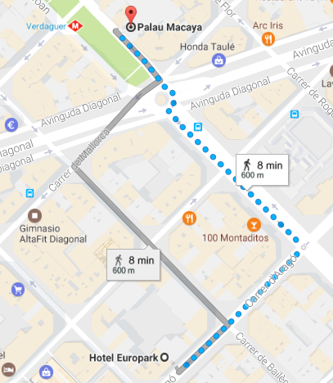

AYRE HOTEL CASPE
http://www.ayrehoteles.com/en/hotel-caspe/
Caspe, 103, 08013 - Barcelona – Spain
Tel: (+34) 93 246 70 15

“Our Hotel 4* situated at the heart of modern Barcelona, offers you an ideal location.

The Ayre Hotel Caspe is situated right in the centre and very near the vibrant district of Poble Nou – Villa Olimpica. Discover this elegant district which is home to the Sagrada Familia, situated between Barcelona's two most active business areas, next to the Arco de Triunfo, moments (8 blocks) from Gaudí's buildings on the historical Passeig de Gràcia and from La Plaza de Catalunya.

Private parking at the hotel and many bus connections, as well as the metro stations Tetuán (L-2) 200 metres away and Arc de Triomf (L-1) 300 metres from the hotel.”

SPECIAL RATES FOR THE CONFERENCE:

- Double Room (individual use): 135 € + VAT (10%)
- Double Room (double use): 140€ + VAT (10%)
http://www.ayrehoteles.com/en/hotel-caspe/rooms/?typeroom=type_6#type_6

Breakfast included!
Touristic tax not included in the price (1,21 € per night and person)
Free WiFi in the entire hotel.

In order to benefit for these special rates just fill in this form (Ayre Hotel Reservation form) and send it to: grupos3.barcelona@ayrehoteles.com to the attention of Carlos Burgos. You can use as a subject for the e-mail: “Reservation for the EIASM Workshop on Talent Management”.

TRANSPORT AND GETTING AROUND:

How to arrive to the hotel:

From the airport:

The easiest option would be a Taxi, you can usually find a cab ride to the hotel for 30€ or 40€ depending on traffic (the time you arrive is about the middle/end of rush hour in Barcelona).
The Taxi ride will usually take between 30 – 35 min.
The second option would be the train from TERMINAL 2, which will get you to BARCELONA - SANTS Train Station (Barcelona’s Central train station). There you can find two of Barcelona’s Metro lines (underground) L3 (green) and L5 (blue). To get to the hotel I would recommend you take L5 up to Sagrada Familia, change to L2 (purple) and finally stop at Tetuan station, which is 3 blocks away from the hotel. One-way tickets on public transport in Barcelona cost 2.15€ (You can also get various daily or weekly tickets depending on how much you want to use public transport. The train ride will take about 25 min. The metro ride from Barcelona-Sants to the hotel will take about the same.

The third option would be to take the Aerobus from the airport, which will take you right up to the City Centre known as Plaça Catalunya. From there it’s a quick taxi ride to the hotel or, if you wish, you can take Metro line L1 (red) up to Arc de Triomf which is also 3 blocks away from the hotel. The Aerobus costs 5,90€, and public transport 2.15€ as mentioned above. The Aerobus ride takes between 25 and 40 min depending on traffic.

More information: http://www.barcelona-tourisguide.com/en/airport/transport/barcelona-airport-aerobus.html

The hotel is just 15 minutes by walk from the Conference Venue:

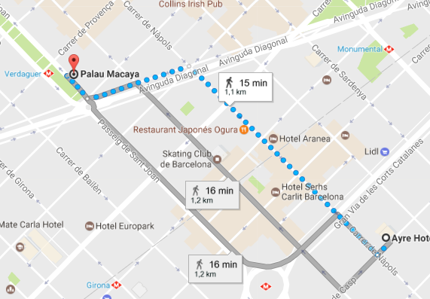

ROOM MATE - CARLA
https://room-matehotels.com/en/carla/hotel-description/
Mallorca, 288, 08037 Barcelona – Spain
Tel: (+34) 93 476 33 96

“Want to experience what it’s like to stay at a boutique design hotel in Barcelona? Room Mate Carla is a modern design hotel decorated by the interior designer Tomás Alía that pays his particular tribute to the Mediterranean minimal look with a touch of color. The unique hotel is located in the city center, in the Eixample area, which is full of history and excitement, not to mention excellent restaurants. Just a few minutes from La Sagrada Familia (Antonio Gaudí masterpiece), Plaza Catalunya and La Ramblas.

When you’re with us, you’ll enjoy the excellent service and premium amenities of a hotel – for example free Wi-Fi all throughout the building and city. But more important, you’ll enjoy the warm hospitality of a friend. That’s what sets us apart. And it starts with the friendly smile we welcome you with.”

SPECIAL RATES FOR THE CONFERENCE:

- Double Standard Room (individual use): 149€ (VAT included)
- Double Standard Room (double use): 149€ (VAT included)
https://room-matehotels.com/en/carla/rooms/
(the special rates only apply to standard rooms; note that all rooms are somehow different)

Breakfast NOT included. (Breakfast buffet at the hotel is 9,95€ per person and day)
Touristic tax not included in the price (1,21 € per night and person)
Free WiFi in the entire hotel.

In order to benefit for these special rates just fill in this form (Room Mate-Carla Reservation form) and send it to: carla.jrecepcion@room-matehotels.com to the attention of Aroa Márquez. You can use as a subject for the e-mail: “Reservation for the EIASM Workshop on Talent Management”.

TRANSPORT AND GETTING AROUND:

How to arrive to Room Mate Carla:

BY CAR:
The exact address of the Room Mate Carla Hotel is: Carrer de Mallorca 288, 08037 Barcelona, Spain. Punch it into your GPS. Or, if you’d like, give us a call at (+34) 93 476 33 96. We’ll be delighted to tell you the best way to get here.

FROM THE CENTRAL TRAIN STATION:
You can reach the Sants train station by regional train or on the high-speed AVE, continue to the hotel by metro. Lines 4 (blue) to Verdaguer station.

FROM THE AIRPORT:
Barcelona Airport: Final stop of AEROBUS shuttle at Plaça de Catalunya, 20 min. Walk from the hotel or direct access via metro Urquinaona (line 5 yellow) to Verdaguer station.
Gerona Airport: Transfer to the city on BARCELONA BUS shuttle with final stop at the Barcelona North bus station and then on to the hotel by bus (stop number 19 in Diagonal with Paseo San Juan)

BY METRO:
If you are arriving by metro line 4 and 5 (green blue and yellow) at Verdaguer station.

BY BUS:
If you are arriving by bus, lines 33, 34 or 6. Your stop will be Avenida Diagonal. 3 mintutes from the hotel.

The hotel is just 7 minutes by walk from the Conference Venue:

